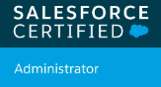 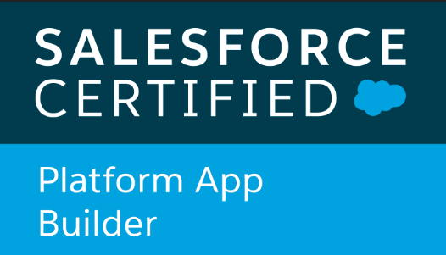 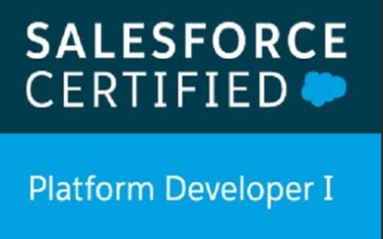 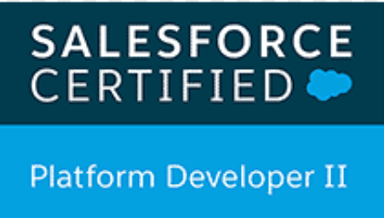 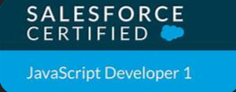 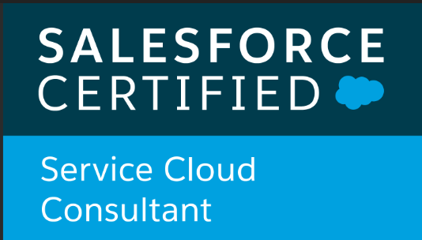 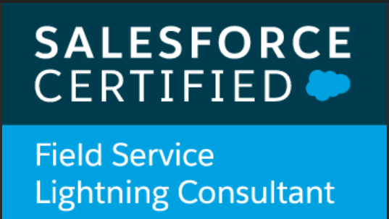

**Phone :+919705556988 | Email:** [**venkatrajumakireddy1997@gmail.com | Tadepalligudem**](mailto:venkatrajumakireddy1997@gmail.com) **A.P**

NAGA VENKAT RAJU MAKIREDDY



Highly seasoned and accomplished Salesforce Developer with a strong record of client satisfaction with 4.6 years of experience. Team collaborator with strong verbal and written communication skills. Looking for opportunities to work on challenging projects with like-minded individuals to help fulfil organizational goals and expand my skills.

**SKILLS :-**

➢ **Backend**: Apex, Apex Triggers, Asynchronous Apex.

➢ **U.I**: Lightning Components (Aura Components, LWC), Visual Force.

➢ **Database**: SOQL, SOSL.

➢ **Automation**: Flows, Process Builder, Workflow Rules, Validation Rules, etc.

➢ **Deployment**: Changesets, VS Code, Git, Metadata Deployment using Ant, SFDX.

**EXPERIENCE**

**Accenture -** System Engineer

FSL Consultant **/** Salesforce Developer Nov 2021 -Present

**Project: 1 Vestas-Field Service(**Dec 2021 – Nov 2023)

➢ Experience setting up field service features according to client unique business needs. This includes installing Field

Service Lightning managed package and Field Service Lightning mobile app.

➢ Experience with setting up FSL data models (Work Orders, Service Appointments, Service Resources, Territories, etc).

➢ Ability to configure Service Rules and Objectives in support of Field Service business processes.

➢ Involved in Data Migration by using Data loader, Workbench.

➢ Worked as Module Lead conducting SCRUM meetings and giving Knowledge Transition to newly joined associates.

➢ Experience in designing and developing Apex Classes, Controller Classes, extensions, and Apex Triggers for various functional needs in application.

**Project: 2 Thames Water-Field Service Developer**(Nov 2023- Present)

➢ Proficient in crafting and delivering diverse backlog user stories within designated sprint timelines to fulfill client

needs effectively.

➢ Actively involved in identifying and rectifying various bugs reported by end users in live production environments.

➢ Played a pivotal role as a team lead, ensuring timely project delivery to clients and fostering team cohesion.

**TCS** Asst System Engineer

Salesforce Developer (July 2019 -May 2021)

**Project -1: Bio Star Next Gen**

➢ Developed Complex Business scenarios using Salesforce.com Out of box functionalities.

➢ Resolved the issues raised by testers on Salesforce CRM application.

➢ Achieved 94 percent plus code coverage for all Apex Test Classes.

➢ Migrated Code to production with various deployment tools like ANT, Change sets etc. and data with data loader of more than 20+k records.

➢ Worked on Admin Tasks like Profiles and Permission sets, validation rules, Process Builder, Workflow rules etc.

➢ Having Knowledge in Integration API’s.

**Project -2 : Vaillant – Field Service**

FSL Consultant **/**Salesforce Developer (May 2021 -Nov 2021)

➢ Resolved the issues raised by testers on Field Service Application

➢ Developed Complex Business scenarios using Salesforce.com Out of box functionalities on Field service application.

CERTIFICATIONS

➢ Salesforce **Java Script Developer I**

➢ Salesforce **Platform Developer II**.

➢ Salesforce **Field Service Consultant.**

➢ Salesforce Service Cloud Consultant.

➢ Salesforce Platform Developer 1.

➢ Salesforce Certified Platform App Builder.

➢ Salesforce Administrator.

**ACHIEVEMENTS**

* Recognized thrice for best performance in Accenture.
* Received 3000 points for best performance
* Received Star Performer Award at TCS.
* Received Appreciation from client for moving code to Production.
* Earned 1000 badges in trailhead.salesforce.com.
* Received 1000 TC’s gems for best performance.

**EDUCATION**

**Sagi Ramakrishnam Raju Engineering College**— B. Tech (IT) 2015 - 2019 with 81%

**Aditya Junior College (**Intermediate -MPC**)**

2013 - 2015 with 94%

**ST . Jone’s E.M School** , Secondary School 2013 with 95%